PharmaSUG 2025 - Paper SD-044

Running the CDISC Open Rules Engine (CORE) in BASE SAS©

Lex Jansen, CDISC, USA

# Abstract

CDISC Conformance Rules are an integral part of the Foundational Standards and serve as the specific guidance to Industry for the correct implementation of the Standards in clinical studies. The overall goal of the CORE Initiative is to provide a governed set of unambiguous and executable Conformance Rules for each Foundational Standard, and to provide an open-source execution engine for the executable Rules which are available from the CDISC Library [1][2]. The source code of the CORE engine is available on the GitHub repository. A Command Line Interface (CLI) is available on the repository which allows users to run the rules under Windows, Mac, and Linux. If users want to run the Engine in their own Python environment or tooling, it can be implemented as it is available on PyPi (Python Package Index).

For SAS users it is not always an option to run applications as a Command Line Interface.

The presentation will begin with a brief overview of CDISC CORE. The CORE Engine will then be covered. Then the presentation will describe a proof of concept where the CDISC CORE CLI commands have been implemented into SAS processes as Python functions in PROC FCMP, passing parameters and code to the Python interpreter and returning the results to SAS. These Python functions can be called and executed by user-defined SAS functions, which can be called from the DATA step or any context where SAS functions are available.

# Introduction

CDISC Conformance Rules are an integral part of the CDISC Foundational Standards and serve as the specific guidance to Industry for the correct implementation of the Standards in clinical studies. The overall goal of the CORE (CDISC Open Rules Engine) Project is to deliver a governed set of unambiguous and executable Conformance Rules for each Foundational Standard, and to provide a reference implementation of an open-source execution engine for the executable Rules which are retrieved from the CDISC Library.

All code used in this paper and the latest version of the paper are available on GitHub: <https://github.com/lexjansen/cdisc-core-sas>.   
When encountering issues with the code, please open an issue at <https://github.com/lexjansen/cdisc-core-sas/issues>.

This paper is based on CORE version v.0.9.3, March 31, 2025.

# CORE Concept

CORE consists of two parts:

* The Conformance Rules (“Rules”)
* The Conformance Rules Engine (“Engine”).

Figure 1 illustrates the CORE concept. CDISC, with the help of the CDISC Community, develops the rules according to the process that governs all CDISC Standards development. The Conformance Rules are stored in the CDISC Library along with the rest of the CDISC standards.

The Engine is an open-source software application whose purpose is to execute the Rules against clinical data and return results. The Engine is made available to the CDISC Community in GitHub and users may deploy it in a variety of processing environments including cloud, on-premises desktop, and on-premises server [3]. The Engine accesses the Rules from the CDISC Library via a Library API when it executes. Users may also add custom Rules for processing. The Engine is written in the Python programming language and comes with a permissive MIT open-source license.

Figure 1 The CORE Concept

# CORE Conformance Rules

In the Rule development process human-readable Rule specifications are expressed in a machine-readable form. The human-readable Rule specification is interpreted by the Rule developer and authored in the CORE Rule Editor using a structured language (YAML). The CORE development team has developed a schema that defines the specific YAML syntax for expressing a Rule in YAML [4].

Just like the CORE Engine, the Rule Editor is open-source software that CDISC has made available for free to the CDISC Community via GitHub and which is listed in the CDISC Open Source Alliance (COSA). It has been released under the permissive MIT open-source license [5].

Figure 2 shows an example of a Rule in YAML. In this case the rule states that required variables (Core = “Req”) must be included in the dataset and cannot be null (lines 46-52). The rule is applicable to 3 SDTMIG versions (lines 7-45). The rule is applicable to all domains and classes (lines 66-72). Line 64 shows the message given: At least one Required variable has a null value.

More information about the CORE rule development process and the governance model for the rules can be found in references [2] and [6].

Figure 2 An Example CORE Rule in YAML

# The CORE Engine

There are several ways to run the CORE Engine:

* As a CLI (Command Line Interface), which allows you to run the rules under Windows, Mac, and Linux. The compiled package can be downloaded, unzipped, and run [7].  
  The repository also contains the steps for creating an executable version.
* Clone the repository and run python core.py from the root of the CORE project with appropriate parameters. See python core.py --help to see the full list of commands [3].
* An alternative to running the validation from the command line is to instead import the rules engine library in Python (available as a package on PyPi) and run rules against data directly (without needing your data to be in XPT format) in your own environment or tooling [8].

This paper is based on version v.0.9.3, specifically the Windows CLI (core-windows.zip, March 31, 2025).

The last two ways of running - using the non-compiled version – require cloning the cdisc-rules-engine GitHub repository and installing dependencies:

* Clone the repository:

git clone https://github.com/cdisc-org/cdisc-rules-engine.git

* Create a virtual environment:

python -m venv <virtual_environment_name>

* Activate the virtual environment:

.\<virtual_environment_name>\Scripts\Activate -- on windows

* Install the requirements.

python -m pip install -r requirements.txt

## Running the CORE Engine as a CLI

After the CORE Command has been downloaded and unzipped users can run CORE from a command prompt. Examples of commands will only be given for the Windows operating system. The commands are similar for other distributions.

To see all available commands run:

.\core –help

Figure 3 shows the available CORE commands.

Figure 3 Available CORE CLI commands

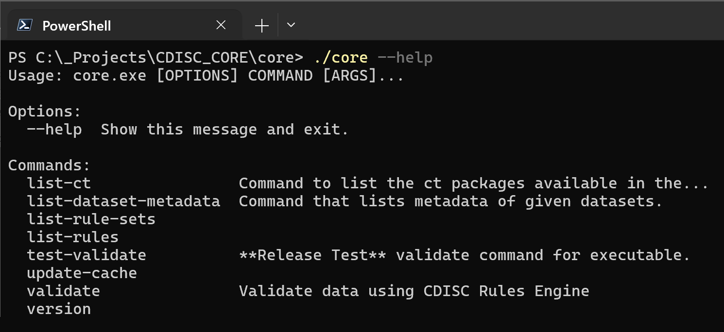

### The CORE Cache

The CORE Engine stores rules and standards metadata from the CDISC Library as Python pickle files in a local cache folder. Pickle files typically have the . pck extension.

“Pickling” is the process whereby a Python object hierarchy is converted into a byte stream, and “unpickling” is the inverse operation, whereby a byte stream (from a binary file or bytes-like object) is converted back into an object hierarchy. Pickling (and unpickling) is alternatively known as “serialization”, “marshalling” or “flattening”; however, to avoid confusion, the terms used here are “pickling” and “unpickling”. [9].

Figure 4 shows an example of a local CORE cache folder on Windows.

Figure 4 CORE local cache folder with pickle files

Rules get added to the CDISC Library on a regular basis. At any moment in time, the locally stored cache can be updated with the update-cache command (see Figure 5) to get the latest set of rules from the CDISC Library. Accessing the CDISC Library requires an API key, which is recommended to define as an environment variable - CDISC_LIBRARY_API_KEY.

To obtain an API key, please follow the instructions found on the CDISC Wiki [10]. Please note it can take up to an hour after signing up to have an API key issued

It is also possible to create custom local rules.

Figure 5 Update the CORE local cache folder with the update-cache command

By default, the update-cache command gets the API key from an environment variable (CDISC_LIBRARY_API_KEY) and the default value for the cache path is: ./resources/cache.  
However, both can be specified as parameters (Figure 6).

Figure 6 Updating the CORE local cache folder with the update-cache command

Warnings like the following can be ignored:

[WARNING 2025-03-30 12:53:48,502 - connectionpool.py:327] - Connection pool is full, discarding connection: api.library.cdisc.org. Connection pool size: 10

### Validating Data

The following command is used to validate data:

.\core validate -s <standard> -v <standard_version> -d path/to/datasets

# ex: .\core.exe validate -s sdtmig -v 3-4 -d .\xpt\

Figure 7 shows all available parameters for the validate command (.\core validate –help).

Figure 7 Parameters for the CORE validate command

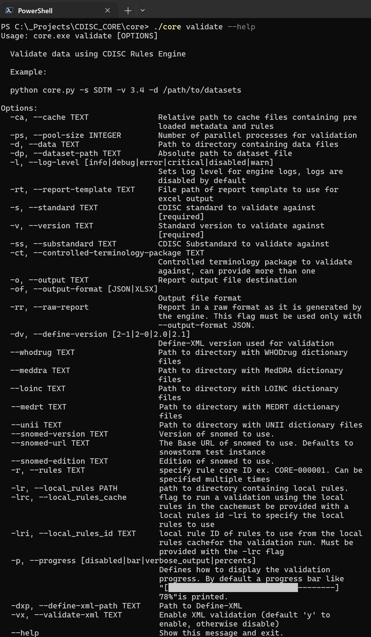

The following command will validate the XPT files in folder ..\data\sdtm against the SDTM-IG 3.3 standard using Define-XML:

.\core validate -s sdtmig -v 3-3 --meddra ../testdata/dictionaries/meddra --whodrug ../testdata/dictionaries/whodrug -d ../testdata/sdtm -dxp ../testdata/sdtm/define.xml -o sdtmig-3-3-report

The result of this command will be an Excel spreadsheet called **sdtmig-3-3-report.xlsx**. Figure 8 shows five screenshots of this spreadsheet.

Figure 8 Validation Report in Excel

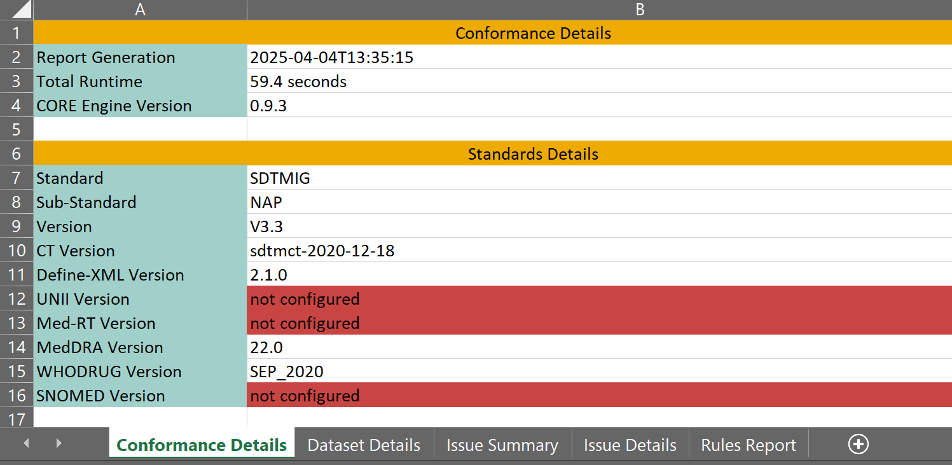

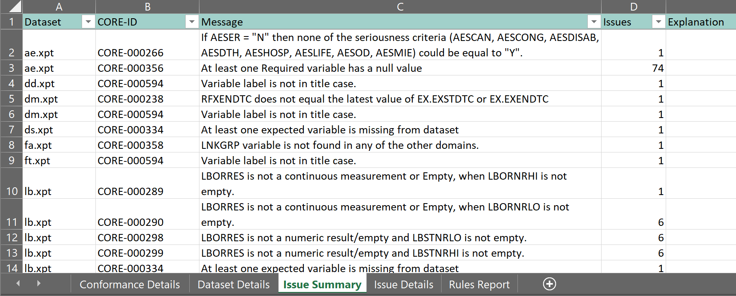

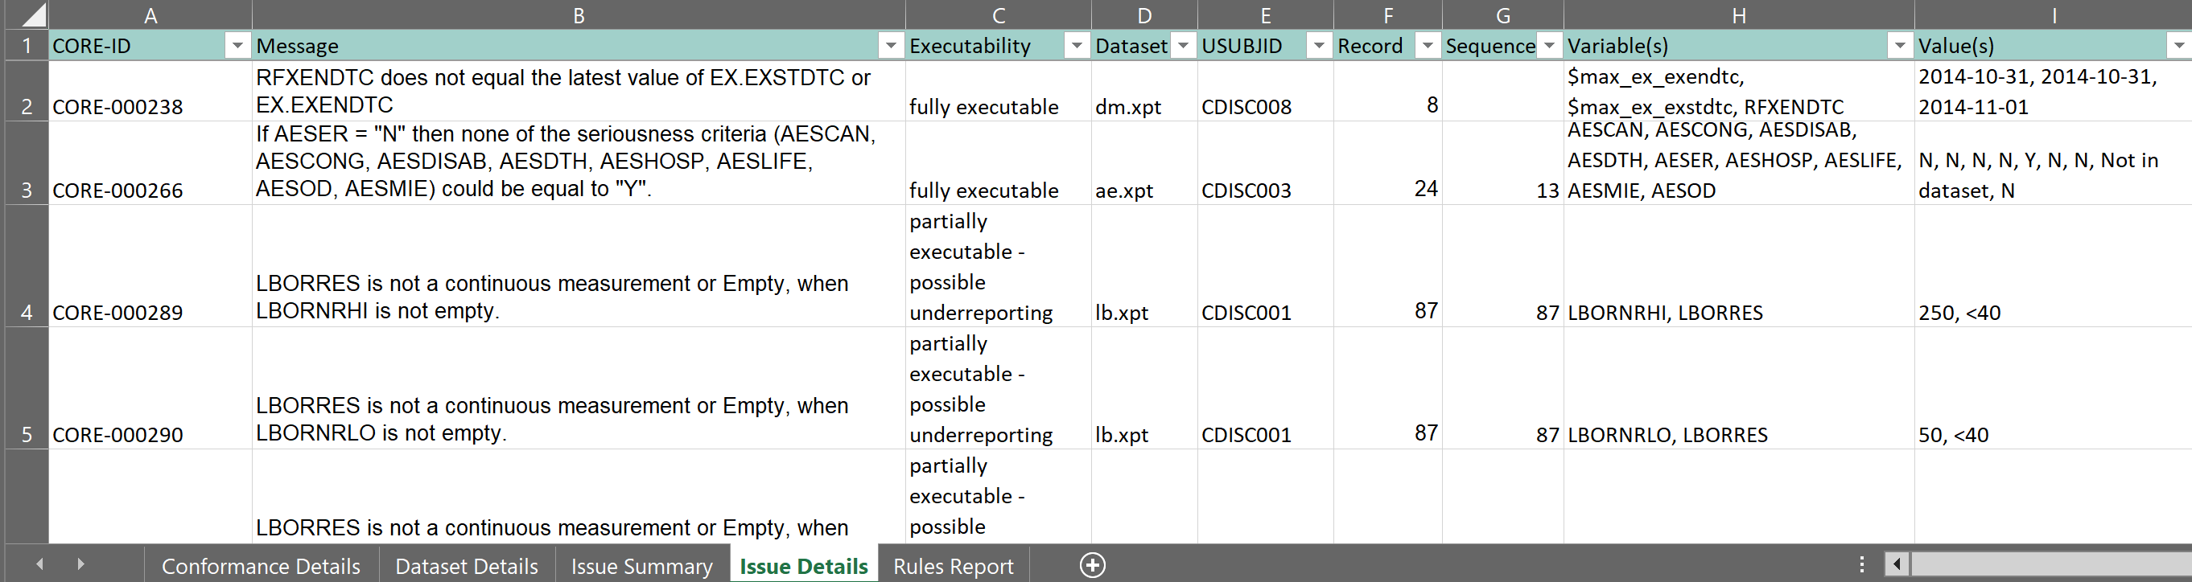

The Rules Report tab displays the run status of each rule selected for validation. The possible rule run statuses are:

* SUCCESS - The rule ran, and data was validated against the rule. May or may not produce results.
* SKIPPED - The rule was unable to be run. Usually due to missing required data but could also be caused by rule execution errors.

After cloning the cdisc-rules-engine GitHub repository and installing dependencies the CLI can also run as a Python program. Here is an example:

python core.py validate -s sdtmig -v 3-3 --meddra ../testdata/dictionaries/meddra --whodrug ../testdata/dictionaries/whodrug -d ../testdata/sdtm -dxp ../testdata/sdtm/define.xml -o sdtmig-3-3-report

# Running the CORE Engine in SAS

## Running a CLI (Command Line Interface) in SAS

SAS has various techniques to execute operating system commands:

* X statement
* SYSTASK statement
* %SYSEXEC statement
* CALL SYSTEM statement
* SYSTEM function
* FILENAMEC statement with the PIPE option

There are a few SAS options related to executing operating system commands:

* XSYNC - Controls whether an X command or statement executes synchronously or asynchronously.
* XWAIT - Specifies whether you must type EXIT at the DOS prompt before the DOS shell closes.
* XMIN - Specifies opening the application specified in the X command in a minimized state or in the default active state.

The following code builds commands to update the cache and then validates data with the CORE engine:

options noquotelenmax;

options noxwait xsync xmin;

%let core_exe = \_Projects\CDISC_CORE\core\core.exe;

%let project_folder = \_Data\presentations\PharmaSUG_2025\SD-044\sandbox;

%let core_cache_folder = &project_folder/resources/cache;

%let core_template = &project_folder/resources/templates/report-template.xlsx;

%let test_data_folder = &project_folder/testdata/sdtm;

%let core_report = &project_folder/reports/sdtmig-3-3-report;

%let core_log = %sysfunc(pathname(work))/core_command;

%let core_command_1 = &core_exe update-cache;

%let core_command_1 = &core_command_1 -c &core_cache_folder;

%let core_command_2 = &core_exe validate;

%let core_command_2 = &core_command_2 -ca &core_cache_folder;

%let core_command_2 = &core_command_2 -rt &core_template;

%let core_command_2 = &core_command_2 -dp &test_data_folder/dm.xpt;

%let core_command_2 = &core_command_2 -dp &test_data_folder/ae.xpt;

%let core_command_2 = &core_command_2 -s sdtmig;

%let core_command_2 = &core_command_2 -v 3-3;

%let core_command_2 = &core_command_2 -dxp &test_data_folder/define.xml;

%let core_command_2 = &core_command_2 -o &core_report;

%let core_command_2 = &core_command_2 -r CORE-000006 -r CORE-000007   
-r CORE-000012 -r CORE-000013 -r CORE-000019 -r CORE-000266 -r CORE-000356;

x "&core_command_1 > ""&core_log._1.log"" 2>&1";

%put &=sysrc;

**data** _null_;

infile "&core_log._1.log" truncover;

input;

put _infile_;

**run**;

x "&core_command_2 > ""&core_log._2.log"" 2>&1";

%put &=sysrc;

**data** _null_;

infile "&core_log._2.log" truncover;

input;

put _infile_;

**run**;

Note:

* The code only validates two datasets: ae.xpt and dm.xpt
* The code only validates against a limited set of rules, using the -r command line option
* Command output is saved to a file (> ""&core_log._1.log"" 2>&1) and printed to the log.

This approach works well, but there can be an issue. The assumption is that the X command is valid in the current SAS session. This may not be the case especially in shared SAS environments. In certain SAS environments SAS administrators may have specified the **NOXCMD** or **XCMD OFF** system options. When specified, the **NOXCMD** options disable the following:

* PIPE and NAMEPIPE device types in the FILENAME statement
* CALL SYSTEM routine
* X command
* Dynamic Data Exchange (DDE)
* %SYSEXEC macro
* SYSTASK statement
* PIPE and NAMEPIPE device types in the FILENAME function.

Indeed, specifying -NOXCMD at SAS invocation results in the following message in the SAS log:

51 ;

ERROR: Shell escape is not valid in this SAS session.

52

53 x "&core_command_1 > ""&core_log._1.log"" 2>&1"

53 ! ;

The remainder of this paper will show how the use of PROC FCMP works around the **NOXCMD** limitation.

The CDISC CORE CLI commands will be implemented into SAS processes as Python functions in PROC FCMP, passing parameters and code to the Python interpreter and returning the results to SAS. These Python functions can be called and executed by user-defined SAS functions, which can be called from the DATA step or any context where SAS functions are available.

## SAS PROC FCMP with Python Support

Starting with the May 2019 release of SAS 9.4M6, the PROC FCMP procedure added support for submitting and executing functions written in Python from within a SAS session using the new Python object. FCMP, or the SAS Function Compiler, enables users to write their own functions and subroutines that can then be called from anywhere a SAS function can be used in SAS. Users are not restricted to using Python only inside a PROC FCMP statement. You can create an FCMP function that calls Python code and then call that FCMP function from the DATA step [11][12].

### Prerequisites

Before you can run Python code in SAS, you must install SAS 9.4M6 (May 2019 update) or later deployments. The following environment setup steps must be completed before you can use PROC FCMP to run the Python code [13].

* Install Python. The CDISC CORE engine requires Python 3.10.
* Set the **MAS_M2PATH** environment variable to specify the absolute path to the mas2py.py file included in your SAS installation. The mas2py.py file is used to execute Python code within a Python process that is launched by SAS Micro Analytic Service.
* Set the **MAS_PYPATH** environment variable to specify the absolute path to the Python executable.

In the SAS example in the GitHub repository (<https://github.com/lexjansen/cdisc-core-sas>) that contains the code used in this paper, the two environmental variables are define in a SAS configuration file:

options set = MAS_PYPATH = "&project_folder/.venv/Scripts/python.exe";

options set = MAS_M2PATH = "%sysget(SASROOT)/tkmas/sasmisc/mas2py.py";

The following (optional) environmental variables can be set in the operating system:

* **MAS_PYLOG_FILE** - Will create a local Python Logging file. Default: Filename is overwritten before logging. '+log.txt': will append data to 'log.txt'.
* **MAS_PYLOG_LEVEL** - The logging level: {ALL, TRACE, DEBUG, INFO, WARN, ERROR, FATAL, OFF}. Default: WARN.
* **MAS_PYOUT_FILE** - Filename for python process STDOUT / STDERR. Default: Filename is overwritten before logging. '+out.txt': will append data to 'out.txt'.

These files can be useful when debugging the execution of Python functions by PROC FCMP.

To be able to run the code that comes with this paper, the user should clone the cdisc-core-sas GitHub repository (<https://github.com/lexjansen/cdisc-core-sas>), create a virtual Python environment, and then install the additional packages that are needed by the CDISC CORE engine:

• Clone the repository:

git clone https://github.com/cdisc-org/cdisc-rules-engine.git

• Create a virtual environment:

python -m venv <virtual_environment_name>

• Install the requirements.

python -m pip install -r requirements.txt

The cdisc-core-sas repository comes bundled with the source code of the v0.9.3 release (March 31, 2025) of the CDISC CORE engine.

Figure 9 shows an example of a cloned cdisc-core-sas repository with a virtual environment (.venv).

Figure 9 Cloned Github repository

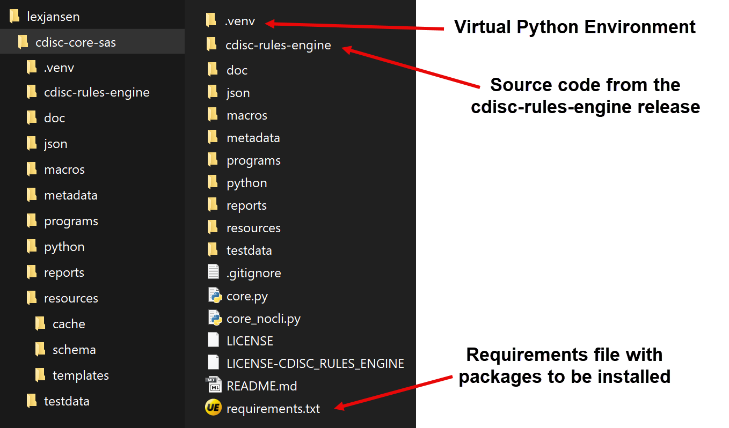

The Python function called by SAS needs to know where to find the cdisc-rules-engine library. For this reason we need an operational system environment variable (**CORE_PATH**) that defines this location of the cdisc-rules-engine library[1].

It is also recommended to create an operational system environment variable (**CDISC_LIBRARY_API_KEY**) that has the API key for accessing the CDISC library.

You may have to work with your SAS administrators to implement these prerequisites.

### PROC FCMP Python Objects

PROC FCMP Python objects enable you to embed and import Python functions into SAS programs. The Python code is not converted to SAS code. Instead, the Python code runs in the Python interpreter of your choice and returns the results to SAS. With a small Python code modification, you can run your Python functions from SAS and easily program in both languages at the same time [14][15].

A typical workflow for using Python objects in PROC FCMP is the following:

* Declare a Python object and a dictionary object
* Insert Python source code into SAS
* Publish Python source code
* Call the Python source code
* Return results from the dictionary

Example:

proc fcmp;

declare object py(python);

submit into py;

def PyProduct(var1, var2):

"Output: MyKey"

newvar = var1 * var2

return newvar,

endsubmit;

rc = py.publish();

rc = py.call("PyProduct", 5, 10);

MyResult = py.results["MyKey"];

file log;

put MyResult=;

run;

The Python object and all the Python object methods are valid only inside a PROC FCMP statement. For example, attempting to declare a Python object in a DATA step program results in an error. However, it is possible to call Python functions from the DATA step by creating PROC FCMP functions or subroutines that contain Python functions. PROC FCMP functions that contain Python functions are valid in the DATA step and can be called like other functions that are created using PROC FCMP.

Also, by using the INFILE method, we can read external source code from a file into a Python object at parse time.

Example:

We have a file (timesfive.py) with the Python code that defines a Python function:

def TimesFive(PythonArg):

"Output: MyKey"

newvar = PythonArg * 5

return newvar

We can create a SAS function MyPyFunc that calls this Python function. We can use MyPyFunc in a data step:

**proc** **fcmp** outlib=work.fcmp.pyfuncs;

function MyPyFunc(FCMParg);

declare object py(python);

submit into py("&project_folder/python/timesfive.py");

rc = py.publish();

rc = py.call("TimesFive",FCMParg);

MyFCMPResult = py.results["MyKey"];

return(MyFCMPResult);

endfunc;

**run**;

options cmplib=work.fcmp;

**data** _null_;

x = MyPyFunc(**5**);

put x=;

**run**;

The LOG file will display x=25.

There are a few limitations related to PROC FCMP functions:

* User-defined functions in PROC FCMP only support positional parameters.
* User-defined functions in PROC FCMP do not support optional parameters.
* User-defined functions in PROC FCMP do not support default values for parameters.

Especially with CORE commands that have many options – like the CORE validate command – these limitations are problematic. Users would have to remember the exact order of the parameters and specify values that are common defaults. A solution for these issues is to wrap the functions in macros that can have named parameters and default values.

### Turning CORE CLI Commands into PROC FCMP Functions

We saw in Figure 3 (Available CORE CLI commands) that the CORE CLI supports several commands. We want to be able to run these commands in SAS. To support this, we will:

* Create Python functions where the command options are function parameters
* Create PROC FCMP functions or subroutines that contain the Python functions
* Create macros that call the functions and subroutines. These macros can also do parameter checks that are not already done by the Python functions.

All CORE CLI commands were implemented (Table 1), except for the **test** command. CORE Rule developers use the test command. The scope for our implementation is the validation of data.

Table 1 CORE CLI commands implementation

|  |  |  |  |
| --- | --- | --- | --- |
| CLI Command | Python Function | PROC FCMP SAS Function | SAS Macro |
| list-ct | core_list_ct | core_list_ct | core_list_ct |
| list-dataset-metadata | core_list_dataset_metadata | core_list_dataset_metadata | core_list_dataset_metadata |
| list-rule-sets | core_list_rule_sets | core_list_rule_sets | core_list_rule_sets |
| list-rules | core_list_rules | core_list_rules | core_list_rules |
| test | - | - | - |
| update-cache | core_update_cache | core_update_cache | core_update_cache |
| validate | core_validate_data | core_validate_data | core_validate_data |
| version | core_version | core_version | - |

In the **cdisc-rules-engine** GitHub repository there is a Python file, core.py, that defines the CORE CLI.

The core.py file uses the Click package to create the command line interface [16].

Appendix 1 shows the Python code in core.py to implement the **validate** command. The Python package imports are not displayed.

To turn this code into a Python function that can be used by PROC FCMP we have to do several things:

* Wrap the code in a Python function, for example core_validate_data.
* Take out all code related to the Python Click package (@click decorators, ctx function argument).
* Replace ctx.exit() statements with return statements, adding return messages where needed.
* Add default values to the Python validate() function.
* Since SAS does not support Tuples, we need to convert a comma separated list into a Python supported datatype, like tuples and lists.
* Move parameter checks from the Click package to the SAS macro,for example %core_validate_data.
* The Python function called by SAS needs to know where to find the cdisc-rules-engine library. For this reason we need an operational system environment variable (CORE_PATH) that defines this location. Every Python function will have code added to find the cdisc-rules-engine library:  
    
   # Add top-level folder to path so that project folder can be found

core_path = os.environ["CORE_PATH"]

lib_path = os.path.abspath(os.path.join(__file__, core_path))

if lib_path not in sys.path: sys.path.append(lib_path)

current_path = os.getcwd()

os.chdir(core_path)

Appendix 2 shows the Python function that is called by SAS PROC FCMP implementing the **validate** command.

Now that the Python functions have been defined, they can be called by a SAS function in PROC FCMP. Below is the code used for the **core_version**, **core_data_validate**, and **core_update_cache** functions:

**proc** **fcmp** outlib = macros.core_funcs.python;

function core_version() $ **32**;

length message $ **128**;

declare object py(python);

submit into py("&project_folder/python/core_version.py");

rc = py.publish();

rc = py.call('core_version');

message = py.results['message_return_value'];

return(message);

endfunc;

function core_validate_data(

cache $, pool_size, data $, dataset_path $, log_level $,  
 report_template $,standard $, version $, substandard $, output $,   
 output_format $, raw_report, controlled_terminology_package $,   
 define_version $, define_xml_path $, validate_xml $,

whodrug $, meddra $, loinc $, medrt $, unii $, snomed_version $,

snomed_edition $, snomed_url $, rules $, local_rules $,

local_rules_cache, local_rules_id $) $ **128**;

length message $ **128**;

declare object py(python);

submit into py("&project_folder/python/core_validate_data.py");

rc = py.publish();

rc = py.call('core_validate_data',

cache, pool_size, data, dataset_path, log_level, report_template,  
 standard, version, substandard, output, output_format,

raw_report, controlled_terminology_package,   
 define_version, define_xml_path, validate_xml,  
 whodrug, meddra, loinc, medrt, unii,

snomed_version, snomed_edition, snomed_url,

rules, local_rules, local_rules_cache, local_rules_id);

message = py.results['message_return_value'];

return(message);

endfunc;

subroutine core_update_cache(apikey $, cache_path $, local_rules $,   
 local_rules_id $, remove_rules $);

declare object py(python);

submit into py("&project_folder/python/core_update_cache.py");

rc = py.publish();

rc = py.call('core_update_cache', apikey, cache_path,   
 local_rules, local_rules_id, remove_rules);

endsub;

...

**run**;

### Creating Macros to Run CORE Commands

The last step is to create macros that call the PROC FCMP functions so that we can define named parameters and default parameter values.

Also, we can do additional parameter validation. Some of the validation checks:

* Does a required parameter have a value?
* Does a file exist?
* Does a folder exist?

Below is an example of a macro, in this case a partial listing of the **core_validate_data** SAS macro.

**%macro** core_validate_data(

cache_path = %sysfunc(sysget(CORE_PATH))/resources/cache,

pool_size = **10**,

data =,

dataset_path =,

log_level = disabled,

report_template = %sysfunc(sysget(CORE_PATH))/resources/templates/report-template.xlsx,

standard =,

version =,

substandard=,

controlled_terminology_package =,

output =,

output_format = XLSX,

raw_report = **0**,  
 define_version =,

define_xml_path =,  
 validate_xml = y,

whodrug =,

meddra =,

loinc =,

medrt =,

unii =,

snomed_version =,

snomed_edition =,

snomed_url = %str(https://snowstorm.snomedtools.org/snowstorm/snomed-ct/),

rules =,

local_rules =,

local_rules_cache = 0,

local_rules_id=

) / minoperator;

...

%*******************************************************************;

%* Parameter checks *;

%*******************************************************************;

...

data _null_;

message = core_validate_data("&cache_path", &pool_size, "&data",

"&dataset_path", "&log_level", "&report_template",

"&standard", "&version", "&substandard", "&output",

"&output_format", &raw_report,"&controlled_terminology_package",

"&define_version", "&define_xml_path", "&validate_xml",

"&whodrug", "&meddra", "&loinc", "&medrt", "&unii",

"&snomed_version", "&snomed_edition", "&snomed_url",

"&rules", "&local_rules", &local_rules_cache, "&local_rules_id");

if not missing(message) then putlog "ERR" "OR: " message;

run;

%exit_macro:

**%mend** core_validate_data;

Parameter descriptions can be found in the macro headers.

## Using MACROS to Run CORE Commands

This section gives examples on the use of the macros that implement the CORE commands.

For every macro there is an example program in programs folder in the GitHub repository (<https://github.com/lexjansen/cdisc-core-sas>).

Before running any of these example programs the user needs to run the **create_core_functions.sas** program in the **programs** folder to create the PROC FCMP functions dataset.

Every example program starts with the same lines of code:

%* This code assumes that your SAS environment can run Python objects. ;

%* Check the programs/config.sas file for Python configuration. ;

%* update this macro variable to your own location;

%let project_folder = /_github/lexjansen/cdisc-core-sas;

%include "&project_folder/programs/config.sas";

Make sure to update the **project_folder** macro variable to your own location.

### %core_update_cache

Purpose: get the latest set of rules and standards metadata from the CDISC Library.

%***core_update_cache***(

/* apikey= <your API key>, */

cache_path = &project_folder/resources/cache

);

This macro call assumes that you have an environment variable CDISC_LIBRARY_API_KEY. If not, you can specify the API key in the macro call.

The result of this macro call is that the latest set of rules and standards metadata from the CDISC Library is extracted to the local cache folder (see Figure 4 CORE local cache folder with pickle files).

### %core_list_ct

Purpose: list the Controlled Terminology packages available in the cache.

filename ct "&project_folder/json/core_ct.json";

%***core_list_ct***(

subsets =,

output = %sysfunc(pathname(ct)),

cache_path = &project_folder/resources/cache

);

**data** _null_;

rc = jsonpp('ct','log');

**run**;

libname jsonfile json fileref=ct;

**data** metadata.core_ct(keep=value rename=(value=ct_package));

set jsonfile.alldata;

**run**;

filename ct clear;

libname jsonfile clear;

The macro extracts a JSON file with the available Controlled Terminology packages in the cache. The JSON file can be easily converted to a SAS dataset as the code demonstrates. The dataset has one variable (ct_package) with the Controlled Terminology package.

Figure 10 core_ct dataset with available Controlled Terminology packages

### %core_list_dataset_metadata

Purpose: list metadata of given datasets.

filename meta "&project_folder/json/core_dataset_metadata.json";

%***core_list_dataset_metadata***(

dataset_path = %str

(&project_folder/testdata/sdtm/dm.xpt,

&project_folder/testdata/sdtm/ae.xpt,

&project_folder/testdata/sdtm/ex.xpt,

&project_folder/testdata/sdtm/lb.xpt),

output = %sysfunc(pathname(meta))

);

**data** _null_;

rc = jsonpp('meta','log');

**run**;

libname jsonfile json fileref=meta ordinalcount=none;

**data** metadata.core_dataset_metadata;

set jsonfile.root;

**run**;

filename meta clear;

libname jsonfile clear;

The macro extracts a JSON file with the dataset metadata. The JSON file can be easily converted to a SAS dataset as the code demonstrates.

Figure 11 core_dataset_metadata with dataset metadata

### %core_list_rule_sets

Purpose: list the rule sets available in the cache.

filename rulesets "&project_folder/json/core_rule_sets.json";

%***core_list_rule_sets***(

output = %sysfunc(pathname(rulesets)),

cache_path = &project_folder/resources/cache

);

**data** _null_;

rc = jsonpp('rulesets','log');

**run**;

libname jsonfile json fileref=rulesets;

**data** metadata.core_rulesets(keep=standard version);

length standard $**32** version $**16**;

set jsonfile.alldata;

standard = strip(scan(value, **1**, ','));

version = strip(scan(value, **2**, ','));

**run**;

**proc** **sort** data = metadata.core_rulesets;

by standard version;

**run**;

filename rulesets clear;

libname jsonfile clear;

The macro extracts a JSON file with the available CORE rulesets in the cache. The JSON file can be easily converted to a SAS dataset as the code demonstrates. The dataset has two variables (standard and version) with the CORE rulesets.

Figure 12 core_rulesets dataset with available CORE rulesets

### %core_list_rules

Purpose: list the rules available in the cache.

filename rules "&json_folder/core_rules_&core_standard.-&core_standard_version..json";

%***core_list_rules***(

output = %sysfunc(pathname(rules)),

standard = &core_standard,

version = &core_standard_version,

cache_path = &project_folder/resources/cache

);

The **core_list_rules** macro extracts a JSON file with the available CORE rules for a given standard and version in the cache. By utilizing the dataset with CORE rules sets, we can extract all rules, organized by standard. We also utilize a macro (**get_core_rules**) to turn the JSON file into a SAS dataset (Figure 13).

**data** _null_;

set metadata.core_rulesets;

length code $ **1024**;

if upcase(standard) = "DDF" then

%* For DDF only get JSON ;

code = cats('%nrstr(%get_core_rules(core_standard=', lowcase(standard), ', core_standard_version=', version, ', dsout=));');

else

code = cats('%nrstr(%get_core_rules(core_standard=', lowcase(standard), ', core_standard_version=', version, '));');

put code=;

call execute(code);

**run**;

This dataset can be used to select rules when validating data, based on standard, standard version, class, domain, and dataset.

Figure 13 core_rules dataset with available CORE rules

### %core_validate_data

Purpose: validate data.

%***core_validate_data***(

cache_path = &project_folder/resources/cache,

data= &project_folder/testdata/sdtm,

standard = sdtmig,

version = **3**-**3**,

output= &project_folder/reports/&report_name._sdtmig_3-**3**,

output_format = %str(XLSX, JSON),

raw_report = **0**,

define_xml_path = &project_folder/testdata/sdtm/define.xml,

validate_xml = y,

whodrug = &project_folder/testdata/dictionaries/whodrug,

meddra = &project_folder/testdata/dictionaries/meddra,

rules =

);

In this example we validate all XPT files in the &project_folder/testdata/sdtm folder,and we are not limiting the rules (rules =). The result will be an Excel spreadsheet similar to the one in Figure 8 together with a JSON file that contains the same content as in the Excel spreadsheet.

Using the core_rules dataset from Figure 12, we can limit the validation to rules that are specific to datasets we want to validate. An example is below. A macro variable **core_rules** is created that contains the applicable rules. We use this macro variable in the **%core_validate_data** macro parameter:  
 rules = "&core_rules"

/* Example of selecting rules */

**proc** **sql** noprint;

select distinct core_id into :core_rules separated by ','

from metadata.core_rules

where (domains_include in ('ALL' 'AE' 'DM')) and   
 (domains_exclude ne 'DM') and   
 (domains_exclude ne 'AE')and  
 (core_standard = "sdtmig" and core_standard_version = "3-3")

order by core_id;

**quit**;

options noquotelenmax;

%***core_validate_data***(

cache_path = &project_folder/resources/cache,

dataset_path = %str

(&project_folder/testdata/sdtm/dm.xpt,

&project_folder/testdata/sdtm/ae.xpt),

standard = sdtmig,

version = **3**-**3**,

output= &project_folder/reports/&report_name._sdtmig_3-**3**,

output_format = %str(XLSX, JSON),

raw_report = **0**,

define_xml_path = &project_folder/testdata/sdtm/define.xml,  
 validate_xml = y,

whodrug = &project_folder/testdata/dictionaries/whodrug,

meddra = &project_folder/testdata/dictionaries/meddra,

rules = "&core_rules"

);

The result will be an Excel spreadsheet similar to the one in Figure 8 together with a JSON file that contains the same content as in the Excel spreadsheet.

# Conclusion

This paper shows that it is possible to implement CDISC CORE Engine CLI commands in the SAS environment. By creating PROC FCMP functions or subroutines that contain Python functions that implement CORE commands, SAS macros can call these Python functions from the DATA step. Named parameters and default values can be easily implemented in SAS macros.

# References

[1] CDISC CORE – Available at <https://www.cdisc.org/core>

[2] de Donder, Nick & Peter van Reusel. (2023). CDISC Conformance rules and the CDISC Open Rules Engine Continuing the Road to Adoption. Proceedings of PHUSE EU Connect 2023.  
Retrieved from <https://phuse.s3.eu-central-1.amazonaws.com/Archive/2023/Connect/EU/Birmingham/PAP_SI04.pdf>

[3] CDISC CORE Engine GitHub Repository. Available at   
<https://github.com/cdisc-org/cdisc-rules-engine>

[4] YAML: YAML Ain't Markup Language™.   
<https://yaml.org/>

[5] CDISC CORE Rules Editor GitHub Repository.   
Available at <https://github.com/cdisc-org/conformance-rules-editor>

[6] Wyckmans, Marisa & Els Janssen (2023). Developing and Implementing CDISC CORE rules: from zero to hero. Proceedings of PHUSE EU Connect 2023.  
Retrieved from: <https://phuse.s3.eu-central-1.amazonaws.com/Archive/2023/Connect/EU/Birmingham/PAP_SI05.pdf>

[7] CDISC CORE Engine GitHub Repository Releases.  
Available at <https://github.com/cdisc-org/cdisc-rules-engine/releases>

[8] cdisc-rules-engine on the Python Package Index (PyPI).   
Available at <https://pypi.org/project/cdisc-rules-engine/>

[9] pickle — Python object serialization. Retrieved from <https://docs.python.org/3/library/pickle.html>

[10] Getting Started: Access to CDISC Library API using API Key Authentication.  
<https://wiki.cdisc.org/display/LIBSUPRT/Getting+Started%3A+Access+to+CDISC+Library+API+using+API+Key+Authentication>

[11] Zizzi, Mike (2019). SAS or Python? Why not use both? Using Python functions inside SAS programs. Retrieved from:   
<https://blogs.sas.com/content/sgf/2019/06/04/using-python-functions-inside-sas-programs/>

[12] SAS Institute. "FCMP Procedure." *Base SAS Procedures Guide*. Available at <https://documentation.sas.com/doc/en/pgmsascdc/9.4_3.5/proc/n0pio2crltpr35n1ny010zrfbvc9.htm>

[13] SAS Institute. "Configuring SAS to Run the Python Language." Configuring SAS to Run External Languages. Available at <https://go.documentation.sas.com/doc/en/bicdc/9.4/biasag/n1mquxnfmfu83en1if8icqmx8cdf.htm>

[14] SAS Institute. "Using PROC FCMP Python Objects." *Base SAS Procedures Guide*. Available at  
<https://documentation.sas.com/doc/en/pgmsascdc/9.4_3.5/lecompobjref/p18qp136f91aaqn1h54v3b6pkant.htm>

[15] SAS Institute. "Python Object Language Elements." *Base SAS Procedures Guide*. Available at  
<https://documentation.sas.com/doc/en/pgmsascdc/9.4_3.5/lecompobjref/p0x7optrcqo9vmn119q1yhxpj35n.htm>

[16] “click” on the Python Package Index (PyPI). Available at <https://pypi.org/project/click/>

# Contact Information

Your comments and questions are valued and encouraged. Contact the author at:

Lex Jansen

Sr Director, Data Science Development, CDISC (contract through Lex Jansen Consulting LLC)

Email: [ljansen@cdisc.org](mailto:ljansen@cdisc.org) or [lexjansen@gmail.com](mailto:lexjansen@gmail.com)

SAS and all other SAS Institute Inc. product or service names are registered trademarks or trademarks of SAS Institute Inc. in the USA and other countries. ® indicates USA registration.

Other brand and product names are registered trademarks or trademarks of their respective companies.

# Appendices

## Appendix 1 : Code in the core-rules-engine Python file core.py to implement the validate command

import asyncio

import json

import logging

import os

import pickle

import tempfile

from datetime import datetime

from multiprocessing import freeze_support

from typing import Tuple

import click

from pathlib import Path

from cdisc_rules_engine.config import config

from cdisc_rules_engine.enums.default_file_paths import DefaultFilePaths

from cdisc_rules_engine.enums.progress_parameter_options import ProgressParameterOptions

from cdisc_rules_engine.enums.report_types import ReportTypes

from cdisc_rules_engine.enums.dataformat_types import DataFormatTypes

from cdisc_rules_engine.models.validation_args import Validation_args

from scripts.run_validation import run_validation

from cdisc_rules_engine.services.cache.cache_populator_service import CachePopulator

from cdisc_rules_engine.services.cache.cache_service_factory import CacheServiceFactory

from cdisc_rules_engine.services.cdisc_library_service import CDISCLibraryService

from cdisc_rules_engine.models.external_dictionaries_container import (

    ExternalDictionariesContainer,

    DictionaryTypes,

)

from cdisc_rules_engine.utilities.utils import (

    generate_report_filename,

    get_rules_cache_key,

    get_local_cache_key,

)

from scripts.list_dataset_metadata_handler import list_dataset_metadata_handler

from version import __version__

def valid_data_file(data_path: list) -> Tuple[list, set]:

    allowed_formats = [format.value for format in DataFormatTypes]

    found_formats = set()

    file_list = []

    for file in data_path:

        file_extension = os.path.splitext(file)[1][1:].upper()

        if file_extension in allowed_formats:

            found_formats.add(file_extension)

            file_list.append(file)

    if len(found_formats) > 1:

        return [], found_formats

    elif len(found_formats) == 1:

        return file_list, found_formats

@click.group()

def cli():

    pass

@click.command()

@click.option(

    "-ca",

    "--cache",

    default=DefaultFilePaths.CACHE.value,

    help="Relative path to cache files containing pre loaded metadata and rules",

)

@click.option(

    "-ps",

    "--pool-size",

    default=10,

    type=int,

    help="Number of parallel processes for validation",

)

@click.option(

    "-d",

    "--data",

    required=False,

    help="Path to directory containing data files",

)

@click.option(

    "-dp",

    "--dataset-path",

    required=False,

    multiple=True,

    help="Absolute path to dataset file",

)

@click.option(

    "-l",

    "--log-level",

    default="disabled",

    type=click.Choice(["info", "debug", "error", "critical", "disabled", "warn"]),

    help="Sets log level for engine logs, logs are disabled by default",

)

@click.option(

    "-rt",

    "--report-template",

    default=DefaultFilePaths.EXCEL_TEMPLATE_FILE.value,

    help="File path of report template to use for excel output",

)

@click.option(

    "-s",

    "--standard",

    required=True,

    default=None,

    help="CDISC standard to validate against",

)

@click.option(

    "-v",

    "--version",

    required=True,

    default=None,

    help="Standard version to validate against",

)

@click.option(

    "-ss",

    "--substandard",

    default=None,

    help="CDISC Substandard to validate against",

)

@click.option(

    "-ct",

    "--controlled-terminology-package",

    multiple=True,

    help=(

        "Controlled terminology package to validate against, "

        "can provide more than one"

    ),

)

@click.option(

    "-o",

    "--output",

    default=generate_report_filename(datetime.now().isoformat()),

    help="Report output file destination",

)

@click.option(

    "-of",

    "--output-format",

    multiple=True,

    default=[ReportTypes.XLSX.value],

    type=click.Choice(ReportTypes.values(), case_sensitive=False),

    help="Output file format",

)

@click.option(

    "-rr",

    "--raw-report",

    default=False,

    show_default=True,

    is_flag=True,

    help=(

        "Report in a raw format as it is generated by the engine. "

        "This flag must be used only with --output-format JSON."

    ),

)

@click.option(

    "-dv",

    "--define-version",

    type=click.Choice(["2-1", "2-0", "2.0", "2.1"]),

    help="Define-XML version used for validation",

)

@click.option("--whodrug", help="Path to directory with WHODrug dictionary files")

@click.option("--meddra", help="Path to directory with MedDRA dictionary files")

@click.option("--loinc", help="Path to directory with LOINC dictionary files")

@click.option("--medrt", help="Path to directory with MEDRT dictionary files")

@click.option("--unii", help="Path to directory with UNII dictionary files")

@click.option("--snomed-version", help="Version of snomed to use.")

@click.option(

    "--snomed-url",

    help="The Base URL of snomed to use. Defaults to snowstorm test instance",

    default="https://snowstorm.snomedtools.org/snowstorm/snomed-ct/",

)

@click.option("--snomed-edition", help="Edition of snomed to use.")

@click.option(

    "--rules",

    "-r",

    multiple=True,

    help="specify rule core ID ex. CORE-000001. Can be specified multiple times",

)

@click.option(

    "--local_rules",

    "-lr",

    required=False,

    type=click.Path(exists=True, readable=True, resolve_path=True),

    help="path to directory containing local rules.",

)

@click.option(

    "--local_rules_cache",

    "-lrc",

    required=False,

    is_flag=True,

    default=False,

    help=(

        "flag to run a validation using the local rules in the cache"

        "must be provided with a local rules id -lri to specify the local rules to use"

    ),

)

@click.option(

    "--local_rules_id",

    "-lri",

    required=False,

    help=(

        "local rule ID of rules to use from the local rules cache"

        "for the validation run. Must be provided with the -lrc flag"

    ),

)

@click.option(

    "-p",

    "--progress",

    default=ProgressParameterOptions.BAR.value,

    type=click.Choice(ProgressParameterOptions.values()),

    help=(

        "Defines how to display the validation progress. "

        'By default a progress bar like "[████████████████████████████--------]   78%"'

        "is printed."

    ),

)

@click.option("-dxp", "--define-xml-path", required=False, help="Path to Define-XML")

@click.option(

    "-vx",

    "--validate-xml",

    default="y",

    help="Enable XML validation (default 'y' to enable, otherwise disable)",

)

@click.pass_context

def validate(

    ctx,

    cache: str,

    pool_size: int,

    data: str,

    dataset_path: Tuple[str],

    log_level: str,

    report_template: str,

    standard: str,

    version: str,

    substandard: str,

    controlled_terminology_package: Tuple[str],

    output: str,

    output_format: Tuple[str],

    raw_report: bool,

    define_version: str,  
 validate_xml: str,

    whodrug: str,

    meddra: str,

    loinc: str,

    medrt: str,

    unii: str,

    snomed_version: str,

    snomed_edition: str,

    snomed_url: str,

    rules: Tuple[str],

    local_rules: str,

    local_rules_cache: bool,

    local_rules_id: str,

    progress: str,

    define_xml_path: str,

):

    """

    Validate data using CDISC Rules Engine

    Example:

    python core.py -s SDTM -v 3.4 -d /path/to/datasets

    """

    # Validate conditional options

    logger = logging.getLogger("validator")

    if raw_report is True:

        if not (len(output_format) == 1 and output_format[0] == ReportTypes.JSON.value):

            logger.error(

                "Flag --raw-report can be used only when --output-format is JSON"

            )

            ctx.exit()

    cache_path: str = os.path.join(os.path.dirname(__file__), cache)

    # Construct ExternalDictionariesContainer:

    external_dictionaries = ExternalDictionariesContainer(

        {

            DictionaryTypes.UNII.value: unii,

            DictionaryTypes.MEDRT.value: medrt,

            DictionaryTypes.MEDDRA.value: meddra,

            DictionaryTypes.WHODRUG.value: whodrug,

            DictionaryTypes.LOINC.value: loinc,

            DictionaryTypes.SNOMED.value: {

                "edition": snomed_edition,

                "version": snomed_version,

                "base_url": snomed_url,

            },

        }

    )

    if data:

        if dataset_path:

            logger.error(

                "Argument --dataset-path cannot be used together with argument --data"

            )

            ctx.exit()

        dataset_paths, found_formats = valid_data_file(

            [str(Path(data).joinpath(fn)) for fn in os.listdir(data)]

        )

        if len(found_formats) > 1:

            logger.error(

                f"Argument --data contains more than one allowed file format ({', '.join(found_formats)})."  # noqa: E501

            )

            ctx.exit()

    elif dataset_path:

        dataset_paths, found_formats = valid_data_file([dp for dp in dataset_path])

        if len(found_formats) > 1:

            logger.error(

                f"Argument --dataset_path contains more than one allowed file format ({', '.join(found_formats)})."  # noqa: E501

            )

            ctx.exit()

    else:

        logger.error(

            "You must pass one of the following arguments: --dataset-path, --data"

        )

        # no need to define dataset_paths here, the program execution will stop

        ctx.exit()

validate_xml_bool = True if validate_xml.lower() in ("y", "yes") else False

    run_validation(

        Validation_args(

            cache_path,

            pool_size,

            dataset_paths,

            log_level,

            report_template,

            standard,

            version,

            substandard,

            set(controlled_terminology_package),  # avoiding duplicates

            output,

            set(output_format),  # avoiding duplicates

            raw_report,

            define_version,

            external_dictionaries,

            rules,

            local_rules,

            local_rules_cache,

            local_rules_id,

            progress,

            define_xml_path,

validate_xml_bool

        )

    )

## Appendix 2 : Python function called by SAS PROC FCMP to implement the validate command

def core_validate_data(cache, pool_size, data, dataset_path, log_level, report_template,   
 standard, version, substandard,

                       output, output_format, raw_report,   
 controlled_terminology_package,   
 define_version, define_xml_path, validate_xml,

                       whodrug, meddra, loinc, medrt, unii, snomed_version,   
 snomed_edition, snomed_url,

                       rules, local_rules, local_rules_cache, local_rules_id):

      """Output: message_return_value"""

      import os

      import sys

      # Add top-level folder to path so that project folder can be found

      core_path = os.environ["CORE_PATH"]

      lib_path = os.path.abspath(os.path.join(__file__, core_path))

      if lib_path not in sys.path: sys.path.append(lib_path)

      current_path = os.getcwd()

      print(f"Current working directory: {current_path}")

      os.chdir(core_path)

      import asyncio

      import json

      import logging

      import os

      import pickle

      from datetime import datetime

      from multiprocessing import freeze_support

      from typing import Tuple

      import re

      from pathlib import Path

      from cdisc_rules_engine.config import config

      from cdisc_rules_engine.enums.default_file_paths import DefaultFilePaths

      from cdisc_rules_engine.enums.progress_parameter_options import ProgressParameterOptions

      from cdisc_rules_engine.enums.report_types import ReportTypes

      from cdisc_rules_engine.enums.dataformat_types import DataFormatTypes

      from cdisc_rules_engine.models.validation_args import Validation_args

      from scripts.run_validation import run_validation

      from cdisc_rules_engine.services.cache.cache_populator_service import CachePopulator

      from cdisc_rules_engine.services.cache.cache_service_factory import CacheServiceFactory

      from cdisc_rules_engine.services.cdisc_library_service import CDISCLibraryService

      from cdisc_rules_engine.models.external_dictionaries_container import (

          ExternalDictionariesContainer,

          DictionaryTypes,

      )

      from cdisc_rules_engine.utilities.utils import generate_report_filename

      from scripts.list_dataset_metadata_handler import list_dataset_metadata_handler

      from version import __version__

      def valid_data_file(data_path: list) -> Tuple[list, set]:

          allowed_formats = [format.value for format in DataFormatTypes]

          found_formats = set()

          file_list = []

          for file in data_path:

              file_extension = os.path.splitext(file)[1][1:].upper()

              if file_extension in allowed_formats:

                  found_formats.add(file_extension)

                  file_list.append(file)

          if len(found_formats) > 1:

              return [], found_formats

          elif len(found_formats) == 1:

              return file_list, found_formats

      def validate(

          standard: str,

          version: str,

          substandard: str = '',

          cache: str = core_path + "/" + DefaultFilePaths.CACHE.value,

          pool_size: int =10,

          log_level: str = 'disabled',

          data: str = '',

          dataset_path: Tuple[str] =[],

          report_template: str = core_path + "/" + DefaultFilePaths.EXCEL_TEMPLATE_FILE.value,

          output_format: Tuple[str] = [ReportTypes.XLSX.value],

          raw_report: bool = True,

          output: str = generate_report_filename(datetime.now().isoformat()),

          controlled_terminology_package: Tuple[str] = [],

          define_version: str = '',  
 validate_xml: str = '',

          rules: Tuple[str] = [],

          local_rules: str = '',

          local_rules_cache: bool = False,

          local_rules_id: str = '',

          define_xml_path: str = '',

          whodrug: str ='',

          meddra: str = '',

          loinc: str = '',

          medrt: str = '',

          unii: str =  '',

          snomed_version: str = '',

          snomed_edition: str = '',

          snomed_url: str = 'https://snowstorm.snomedtools.org/snowstorm/snomed-ct/',

          progress: str = 'disabled'

      ):

          """

          Validate data using CDISC Rules Engine

          Example:

          python core.py -s SDTM -v 3.4 -d /path/to/datasets

          """

          validation_message = ""

          dataset_path = [item.strip(' ') for item in dataset_path if item !='']

          output_format = [item.strip(' ') for item in output_format if item !='']

          controlled_terminology_package = [item.strip(' ') for item in controlled_terminology_package if item !='']

          rules = [item.strip(' ') for item in rules if item !='']

          if not log_level:

              log_level = 'disabled'

          # Validate conditional options

          logger = logging.getLogger("validator")

          if raw_report is True:

              if not (len(output_format) == 1 and output_format[0] == ReportTypes.JSON.value):

                  logger.error(

                      "Flag --raw-report can be used only when --output-format is JSON"

                  )

                  validation_message = "Flag --raw-report can be used only when --output-format is JSON"

                  return validation_message

          cache_path: str = os.path.join(os.path.dirname(__file__), cache)

          # Construct ExternalDictionariesContainer:

          external_dictionaries = ExternalDictionariesContainer(

              {

                    DictionaryTypes.UNII.value: unii,

                    DictionaryTypes.MEDRT.value: medrt,

                    DictionaryTypes.MEDDRA.value: meddra,

                    DictionaryTypes.WHODRUG.value: whodrug,

                    DictionaryTypes.LOINC.value: loinc,

                    DictionaryTypes.SNOMED.value: {

                        "edition": snomed_edition,

                        "version": snomed_version,

                        "base_url": snomed_url,

                    },

                }

          )

          if data:

              if dataset_path:

                  logger.error(

                      "Argument --dataset-path cannot be used together with argument --data"

                  )

                  validation_message = "Argument --dataset-path cannot be used together with argument --data"

                  return validation_message

              dataset_paths, found_formats = valid_data_file(

                  [str(Path(data).joinpath(fn)) for fn in os.listdir(data)]

              )

              if len(found_formats) > 1:

                  logger.error(

                      f"Argument --data contains more than one allowed file format ({', '.join(found_formats)})."

                  )

                  validation_message = "Argument --data contains more than one allowed file format: " + ", ".join(found_formats)

                  return validation_message

          elif dataset_path:

              dataset_paths, found_formats = valid_data_file([dp for dp in dataset_path])

              if len(found_formats) > 1:

                  logger.error(

                      f"Argument --dataset-path contains more than one allowed file format ({', '.join(found_formats)})."

                  )

                  validation_message = "Argument --dataset-path contains more than one allowed file format: " + ", ".join(found_formats)

                  return validation_message

          else:

              logger.error(

                  "You must pass one of the following arguments: --dataset-path, --data"

              )

              validation_message = "You must pass one of the following arguments: --dataset-path, --data"

              # no need to define dataset_paths here, the program execution will stop

              return validation_message

validate_xml_bool = True if validate_xml.lower() in ("y", "yes") else False

    run_validation(

              Validation_args(

                  cache_path,

                  pool_size,

                  dataset_paths,

                  log_level,

                  report_template,

                  standard,

                  version,

                  substandard,

                  set(controlled_terminology_package),  # avoiding duplicates

                  output,

                  set(output_format),  # avoiding duplicates

                  raw_report,

                  define_version,

                  external_dictionaries,

                  rules,

                  local_rules,

                  local_rules_cache,

                  local_rules_id,

                  progress,

                  define_xml_path,  
 validate_xml_bool

              )

          )

          return validation_message

      return_message = validate(

           cache=cache,

           pool_size=int(pool_size),

           data=data,

           dataset_path=re.split(';|,', dataset_path),

           log_level=log_level,

           report_template=report_template,

           standard=standard,

           version=version,

           substandard=substandard,

           output=output,

           output_format=re.split(';|,', output_format),

           raw_report=(raw_report == 1),

           controlled_terminology_package=re.split(';|,', controlled_terminology_package),

           define_version=define_version,

           whodrug=whodrug,

           meddra=meddra,

           loinc=loinc,

           medrt=medrt,

           unii=unii,

           snomed_version=snomed_version,

           snomed_edition=snomed_edition,

           snomed_url=snomed_url,

           rules=re.split(';|,', rules),

           local_rules=local_rules,

           local_rules_cache=local_rules_cache,

           local_rules_id=local_rules_id,  
 define_xml_path=define_xml_path,

validate_xml=validate_xml

       )

      return return_message

1. The repository related to this paper (<https://github.com/lexjansen/cdisc-core-sas>) includes the latest release of the cdisc-rules-engine repository (<https://github.com/cdisc-org/cdisc-rules-engine>) in the cdisc-rules-engine folder. The code related to this paper has been tested with the CORE_PATH environment variable pointing to this folder. You can point the CORE_PATH environment variable to a development version of the cdisc-rules-engine repository. However, you may have to update Python functions and macros to make the code related to this paper work with this development version. It is the intention of the author to update the code in <https://github.com/lexjansen/cdisc-core-sas> when new release of the CORE engine are released.